**OBJECTIVES:**

* To design and fabricate a linearly polarized rectangular/square microstrip patch antenna on a given FR-4 epoxy substrate of thickness 1.6 mm and dielectric constant 4.4 at a frequency of 2.4 GHz using HFSS software
* To measure the antenna parameters like return loss, radiation pattern and antenna gain.

**THEORY:**

Micro strip antennas are low-profile antennas. A metal patch mounted at a ground level with a di-electric material in-between constitutes a Micro strip or Patch Antenna. These are very low size antennas having low radiation. The radiation pattern of microstrip or patch antenna is broad. It has low radiation power and narrow frequency bandwidth. Microstrip antennas find many applications as they are light weight, conformable to surface and inexpensive to manufacture using printed-circuit technology. Microstrip patch antennas are becoming increasingly useful because they can be printed directly onto a circuit board.

**RETURN LOSS:** The return loss represents how much feeding power that was reflected back at the port of patch antenna as a result of the mismatches between the transmission line and the feeding points. When the antenna and transmission line are not perfectly matched, reflections at the antenna port travel back towards the source and cause a standing wave to form. Good antenna must have high return loss.

**VSWR**: VSWR shows how much power is reflected back from the antenna towards the source. The good value that accepted for antenna is 1≤ VSWR ≥2. If the VSWR value equals 1, means all of the given power to the antenna is transmitted.

**RADIATION PATTERN:** The energy radiated by antenna is represented by radiation pattern of the antenna. There are a few types of radiation pattern such as 3D radiation pattern, 2D radiation pattern and Lobe formation radiation pattern.

**GAIN:** The gain of an antenna is defined as the ratio of intensity in a given direction to the radiation intensity that is obtained if the power accepted by the antenna is radiated in an isotropic manner. An antenna is not a lossless system, and some energy entering the antenna terminals is lost due to heat losses etc. The gain of an antenna describes the rates of power transmitted to peak radiation through isotropic source.

**Construction & Working of Micro strip Antennas**: Micro strip antenna consists of a very thin metallic strip placed on a ground plane with a di-electric material in-between. The radiating element and feed lines are placed by the process of photo-etching on the di-electric material. Usually, the patch or micro-strip is choosen to be square, circular or rectangular in shape for the ease of analysis and fabrication.

For a rectangular patch, the length L of the element is usually L <λg/2 (where λg is the guided wavelength in the substrate). Thicker substrates with lower dielectric constant provide better efficiency and larger bandwidth but at the expense of larger element size. Thin substrates with higher dielectric constants lead to smaller element sizes, minimize coupling, but are less efficient and have relatively smaller bandwidths.

Here we taking the length of the metal patch is λ/2. When the antenna is excited, the waves generated within the di-electric undergo reflections and the energy is radiated from the edges of the metal patch, which is very low. The following image shows a micro-strip or patch antenna.

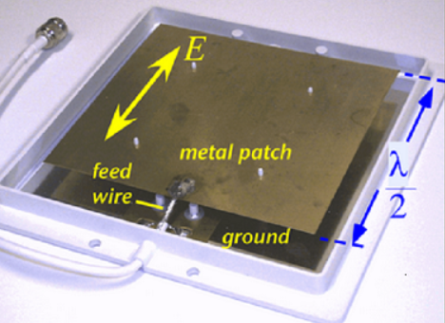 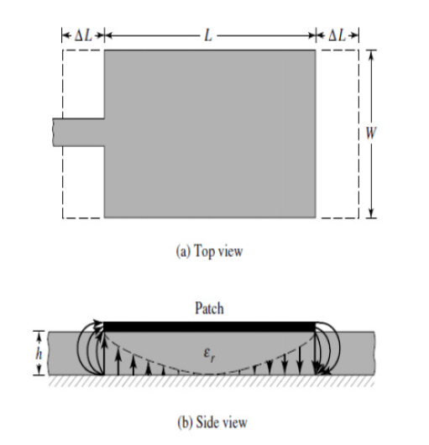

Fig.1. Microstrip Patch Antenna: Fig.1(a)Top view of Patch and Fig.1(b) The field variation across the length of the patch.

The normalized impedance along the length of the patch is typically like as shown in Fig. 2, maximum resistance at the edges is typically 150 – 300 _ and at the center, it is a short circuit.

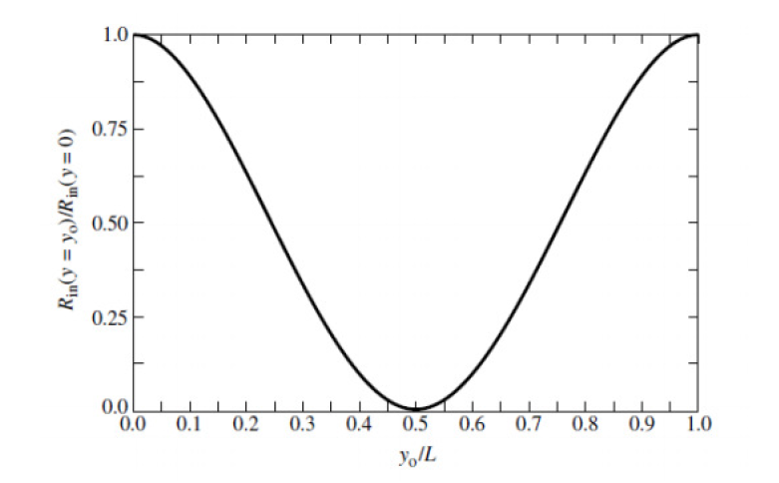

Fig. 2. Normalized Impedance along the length of the patch

### Advantages of MPA

The following are the advantages of Micro strip antenna:

* Lightweight
* Low cost
* Ease of installation

### Disadvantages of MPA

The following are the disadvantages of Micro strip antenna:

* Inefficient radiation
* Narrow frequency bandwidth

### Applications of MPA

The following are the applications of Micro strip antenna:

* Used in Space craft applications
* Used in Air craft applications
* Used in Low profile antenna applications

There are several Parameters which will be used in this designing and fabrication process of Microstrip Patch antenna. They are given below:

1. Formula for width of the Patch

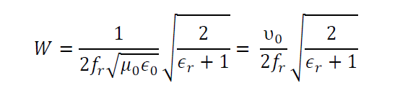

2. Formula for effective dielectric constant for (W/h>1)

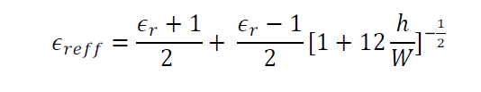

3. Formula for the length correction in the patch length considering fringing effect

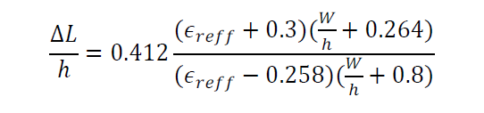

4. Formula for the length of the Patch

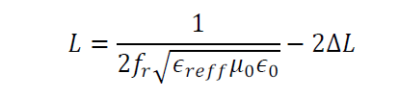

5. The feed point position for 50 _ can be calculated using the following expression

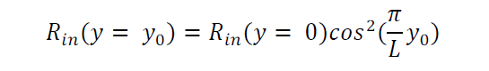

Here, Rin (y = y0) is 50 Ω and Rin (y = 0) is roughly given as (neglecting the mutual coupling of the slots).

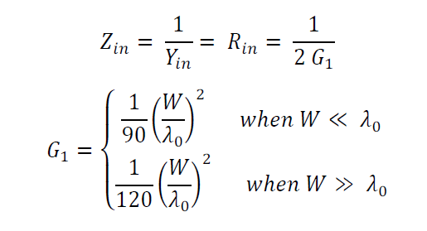

Here, we are getting all the dimensions using MATLAB code which is mentioned in the manual of experiment 6. All the dimensions, i am going to mention below which I have got from the MATLAB code.

* Length of the feed-line is 61.8mm
* Ɛreff = 4.0857
* Width of the feed-line is 3.059mm
* Length of the patch = 29.422mm
* Width of the patch = 38.01mm
* Inset = 8.5525mm

Some values which are given in the manual are :

* Frequency = 2.4 GHz
* Ɛsub =4.4
* tsub =1.6mm
* h1=1.6mm (substrate thickness)
* Zc =50Ω

Substrate dimension are choosen by me as length = 138.01mm and width = 135.917mm.

**CIRCUIT DIAGRAM:**

Using all the above dimensions, we have designed this circuit of Microstrip patch antenna on HFSS software which is shown below.

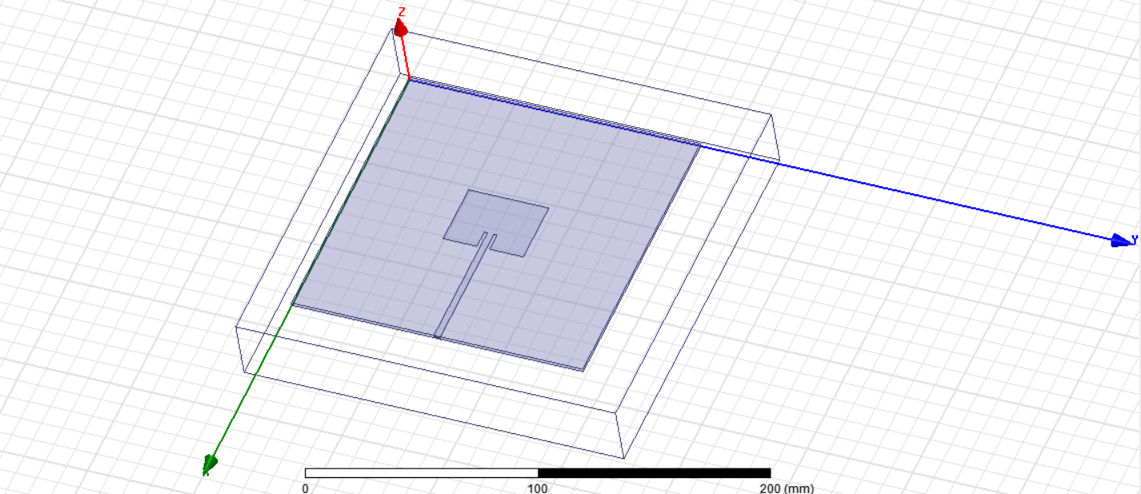

**RESULTS AND PLOTS OBTAINED:**

**1. Plot for Return loss as sS11**

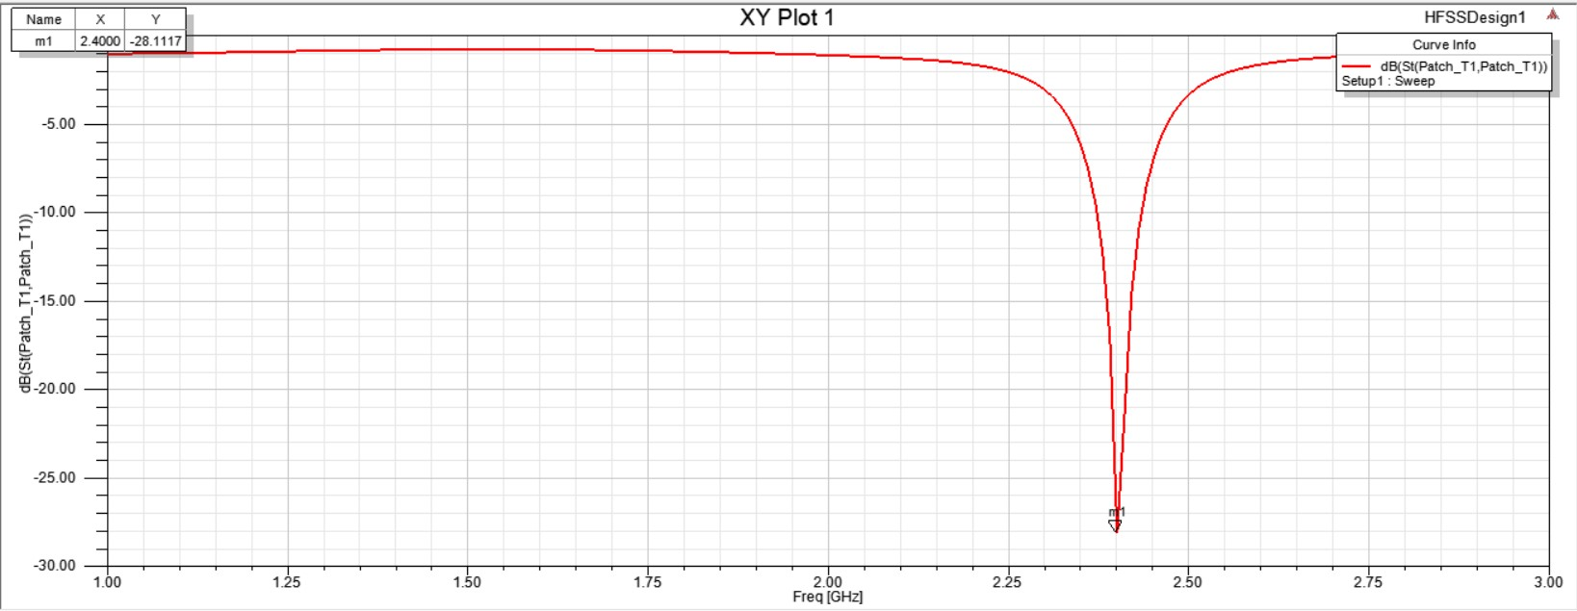

At point m1, we are getting the value of S11 is -28.1117dB at resonant frequency of 2.4GHz.

**2. Plot for VSWR**

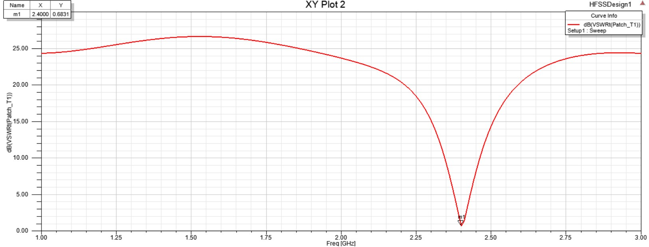

We are getting the value of VSWR at resonant frequency is 0.6831dB.

**3. Plot of Radiation pattern in 2D for all phi values**

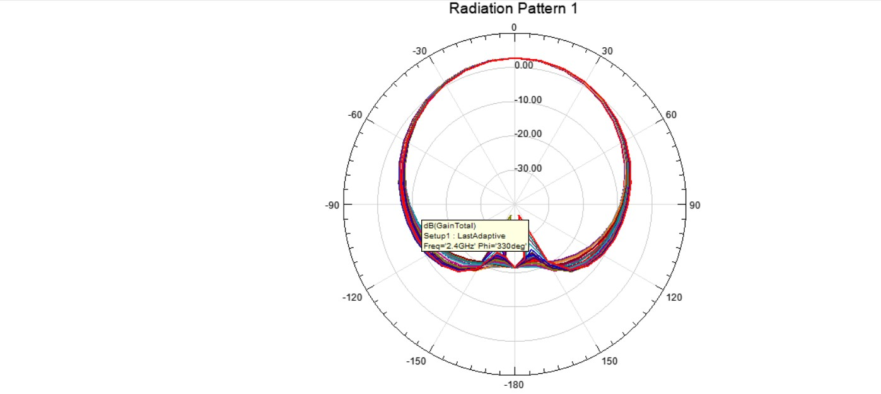

**4. Plot of Radiation pattern in 2D for phi values of 900 degree**

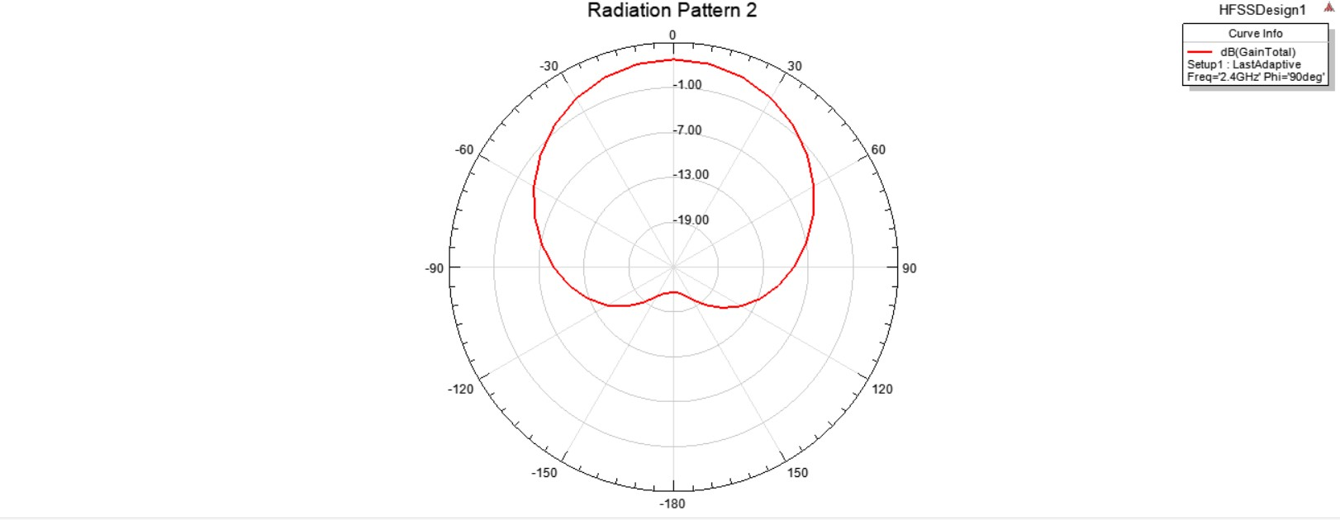

**5. Plot of Radiation pattern in 3D**

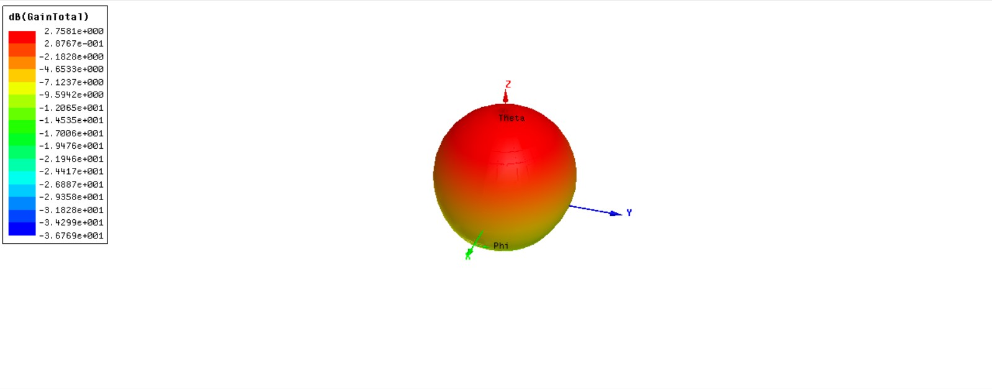

From this 3D radiation plot, gain is 2.7581dB.

**OBSERVATIONS:**

We observed that the antenna simulation give the value for return loss below -10dB which is the value for the design antenna is -28.1117dB at frequency 2.4GHz. We got the value of VSWR which is equal to 0.6831dB. Gain value which we observed from the 3D radiation pattern is 2.7581dB.

**CONCLUSIONS:**

We have achieved our objective here. A microstrip antenna for FR-4 epoxy substrate bands has been successfully designed in a single patch with 50 Ω probe feed. We have studied about the microstrip patch antenna, their applications and we designed it and simulate it on HFSS software. We got to know about working principle of microstrip patch antenna. After designing we got its all parameters. We learned how to design microstrip patch antenna on HFSS software and how to calculate return loss, getting VSWR, radiation pattern in 2D as well as in 3D using this software.